Sri Lanka Institute of Information Technology



Assignment 1

MLB_10.2_11

**AUTOMATED PARKING SYSTEM**

**Internet and Web Technologies – IT1100**

B.Sc. (Hons) in Information Technology

**Group Details**

Group Number: MLB­_10.2_11

Project Title: Automated parking system

|  |  |  |  |  |
| --- | --- | --- | --- | --- |
|  | **Student ID** | **Student Name** | **Email** | **Contact Number** |
| 1 | IT23830332 | PATHIRANA P U O R | IT23830332@my.sliit.lk | 0716792331 |
| 2 | IT23846340 | BANDARA R M K D | IT23846340@my.sliit.lk | 0719678767 |
| 3 | IT23844742 | DHARMASENA S D R H | IT23844742@my.sliit.lk | 0762359036 |
| 4 | IT23725010 | PERERA I V | IT23725010@my.sliit.lk | 0701346360 |
| 5 | IT23827080 | KURUPPU K A S D | IT23827080@my.sliit.lk | 0704415497 |

# **Introduction**

introducing Park pal Swift—the fully automated parking solution in Colombo to take your parking experience into a new realm with modern technology.

Our system provides access to the facility on a 24-hour basis upon subscription through a convenient monthly rental payment for our registered users. It caters to different user roles, from general users to registered members, administrators, security, and support teams, just to name a few. It offers top security levels with a user-friendly interface to manage parking access and payments easily.

We also provide a very strong support system available across diversified channels for quick help and support. Please check our support page for more details or to submit an inquiry. Park pal Swift strives to help you park in Colombo more conveniently and efficiently.

# **Personas**

* 1. Registered user

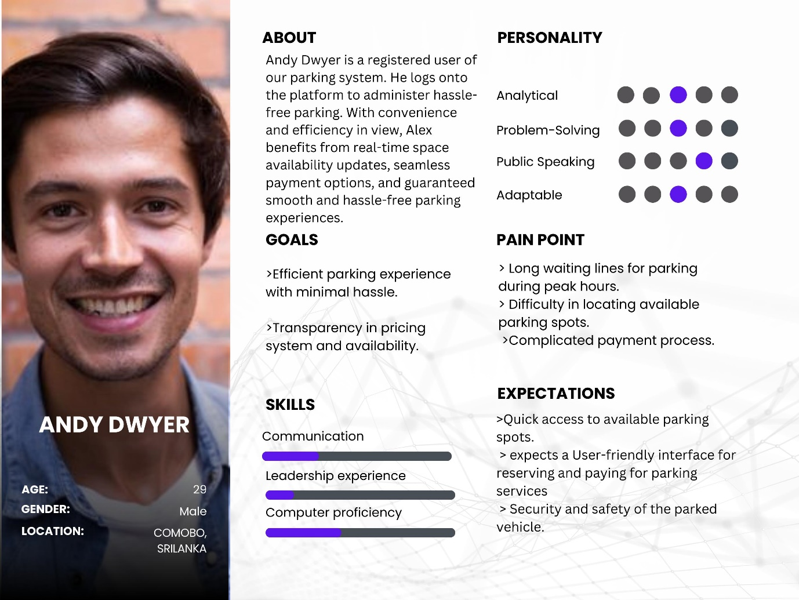

* 1. Administrator

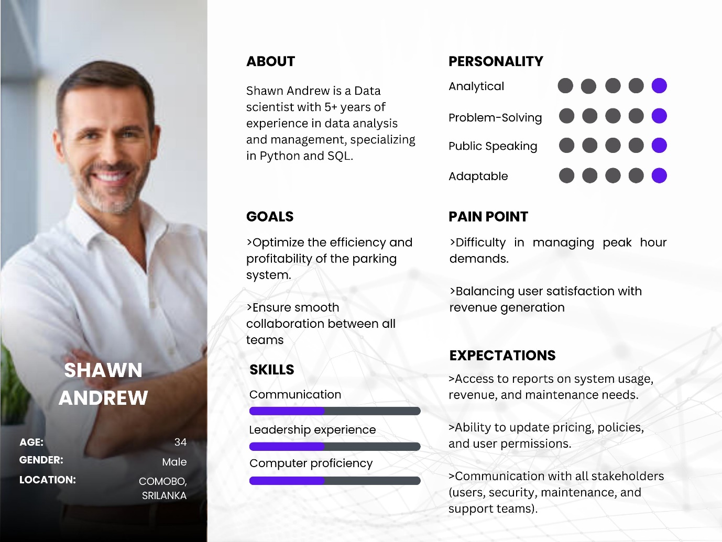

* 1. System user

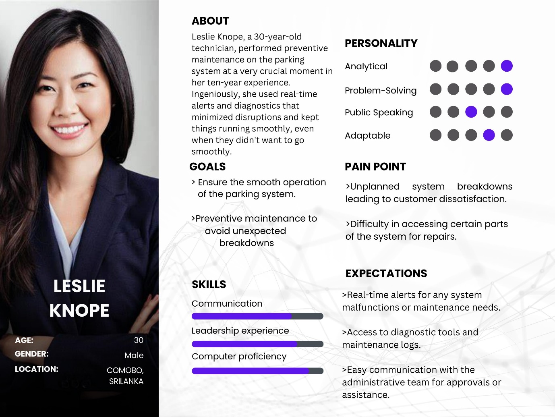

* 1. Security

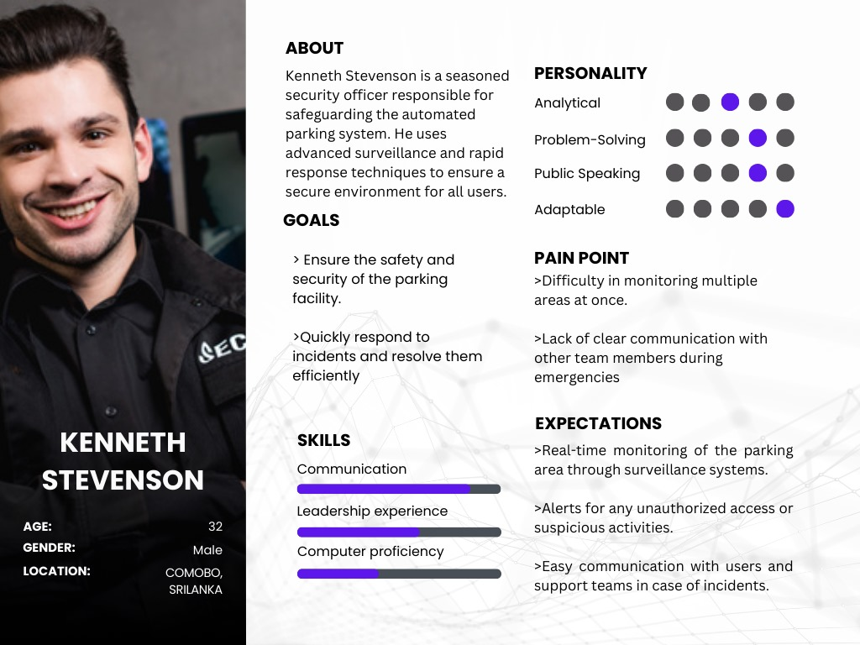

* 1. support

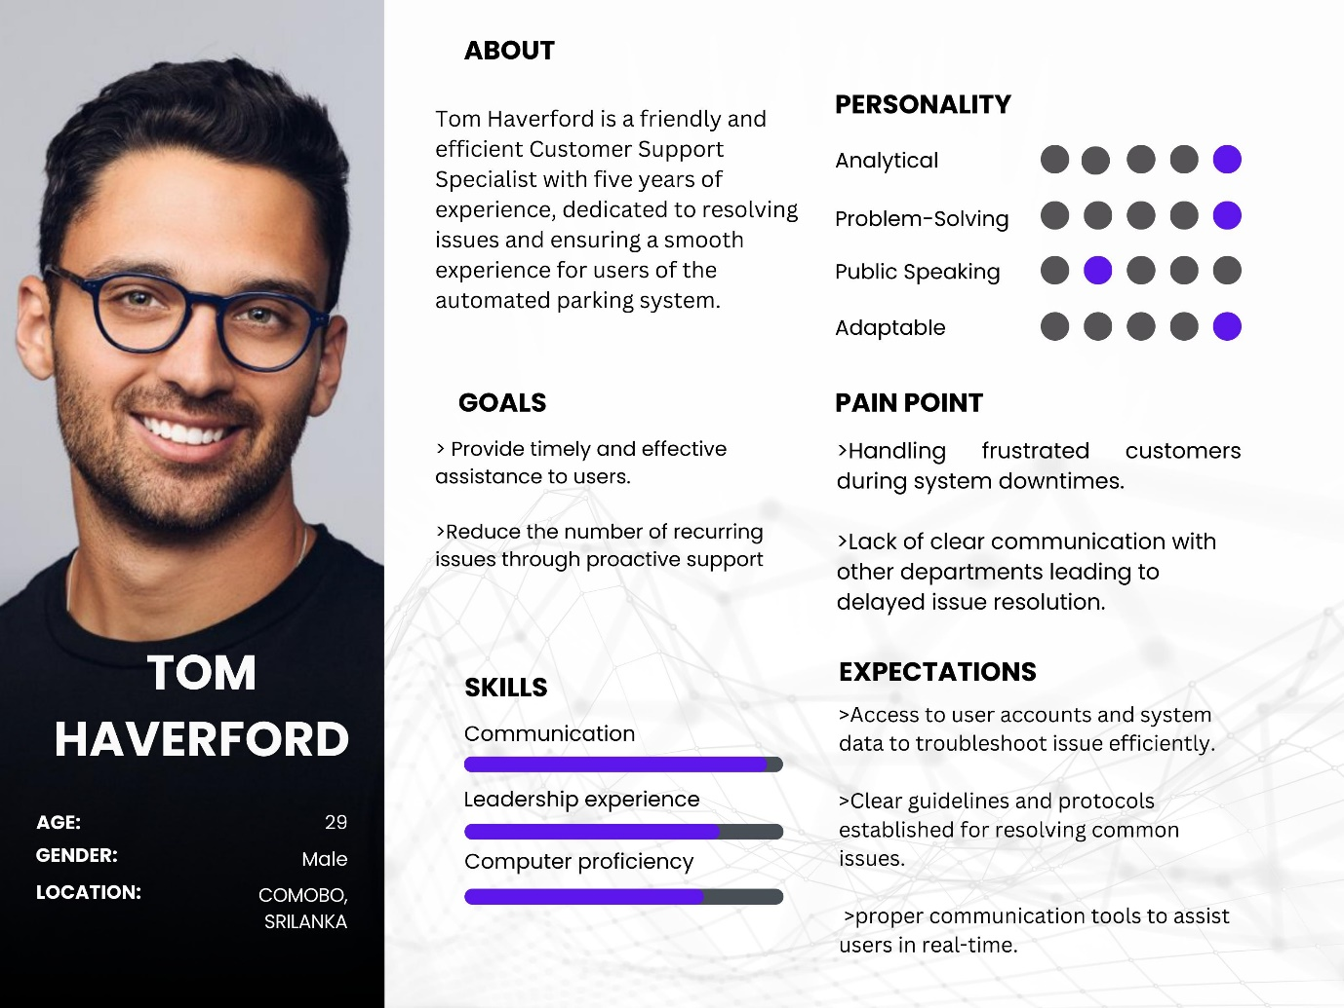

# **User Journeys**

* 1. User

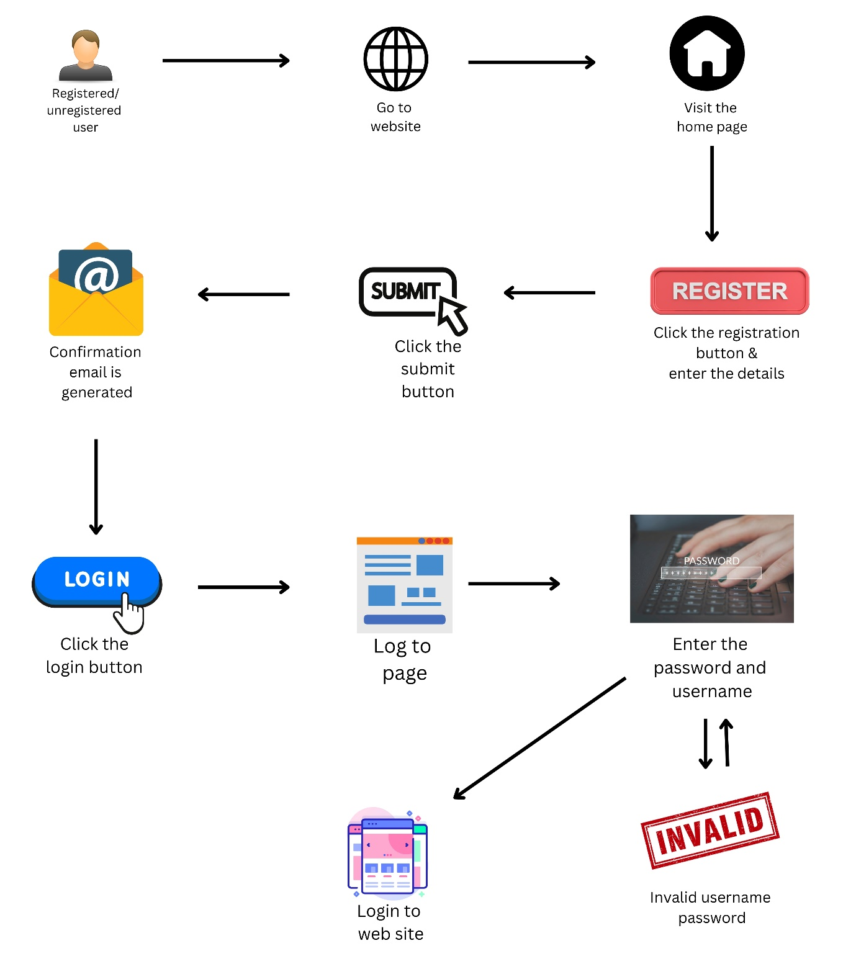

* 1. Registered user

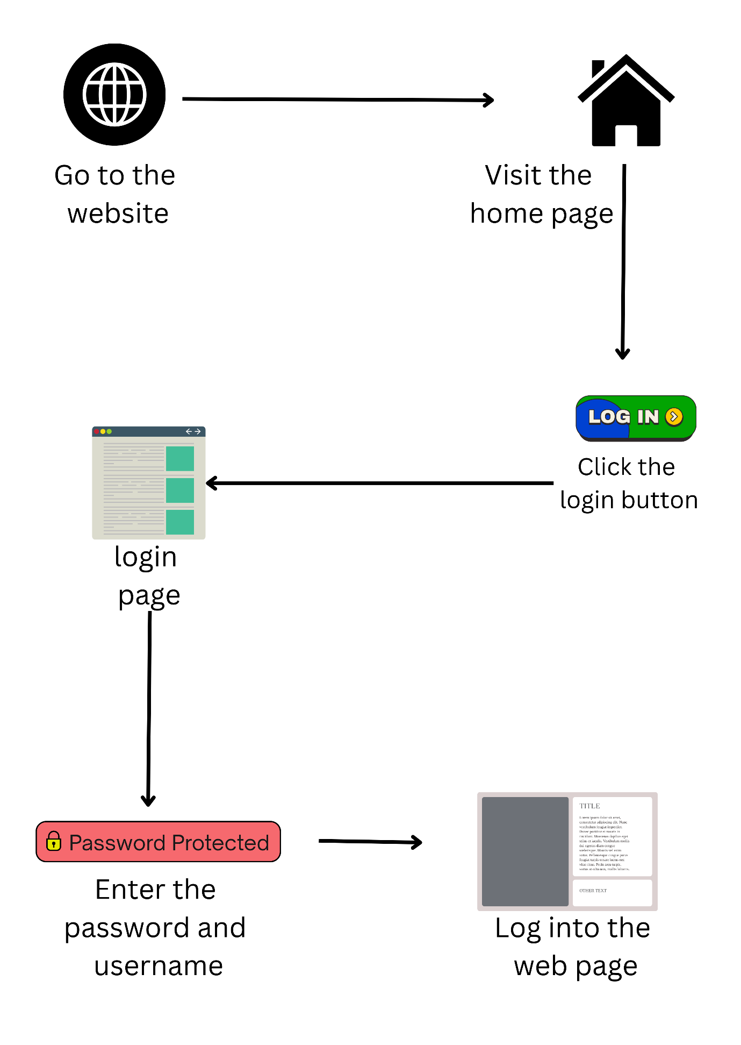

* 1. System user

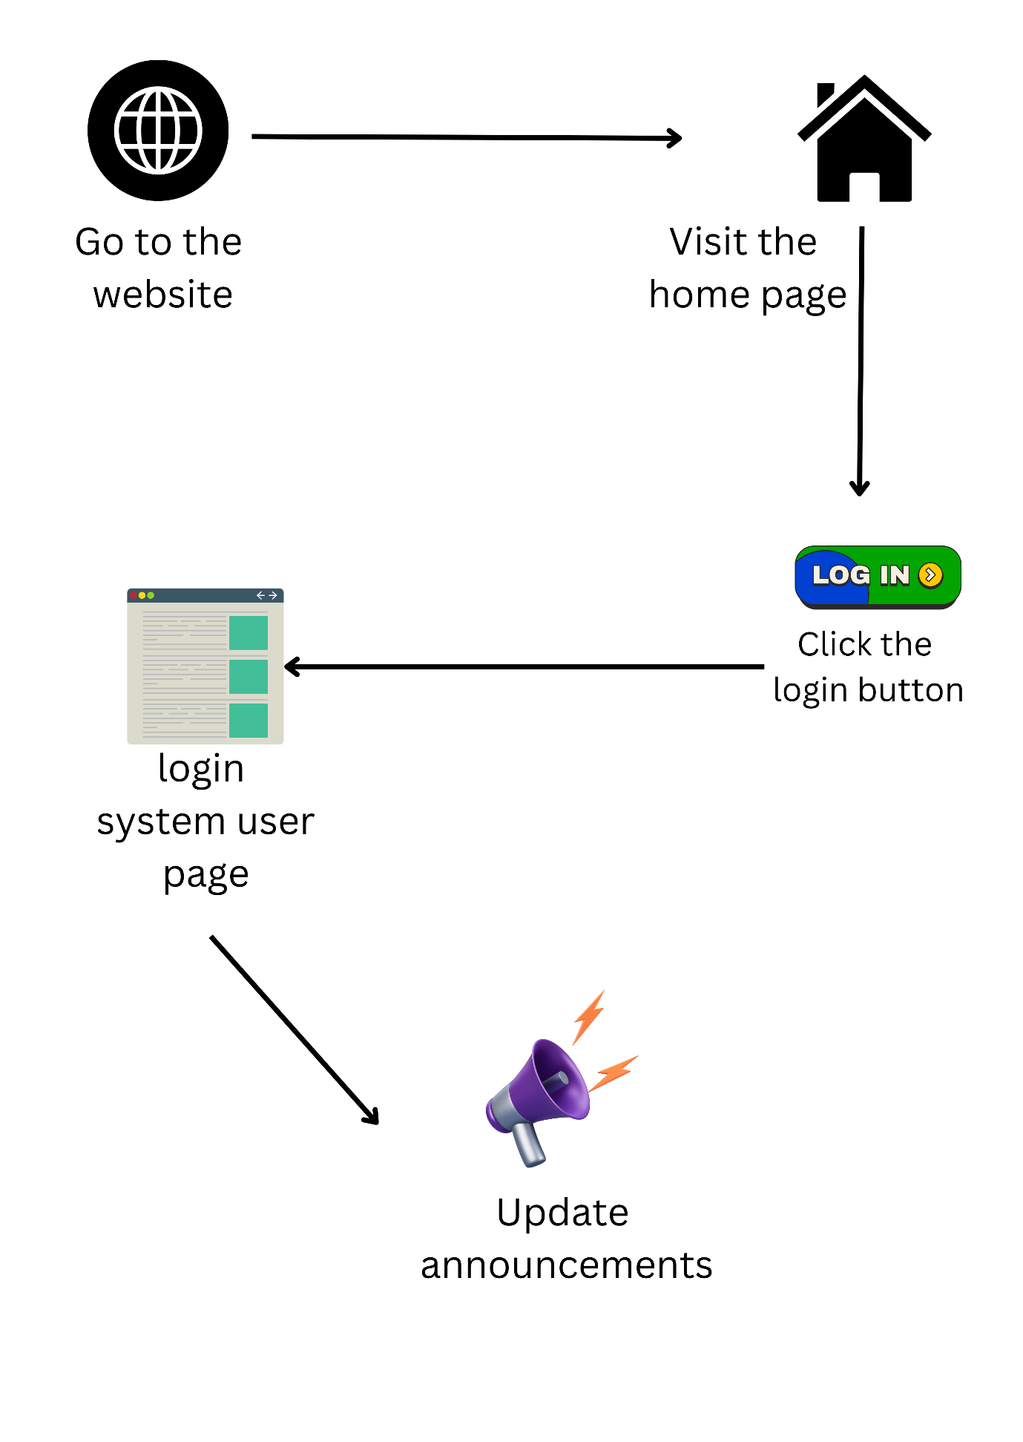

* 1. Administrator

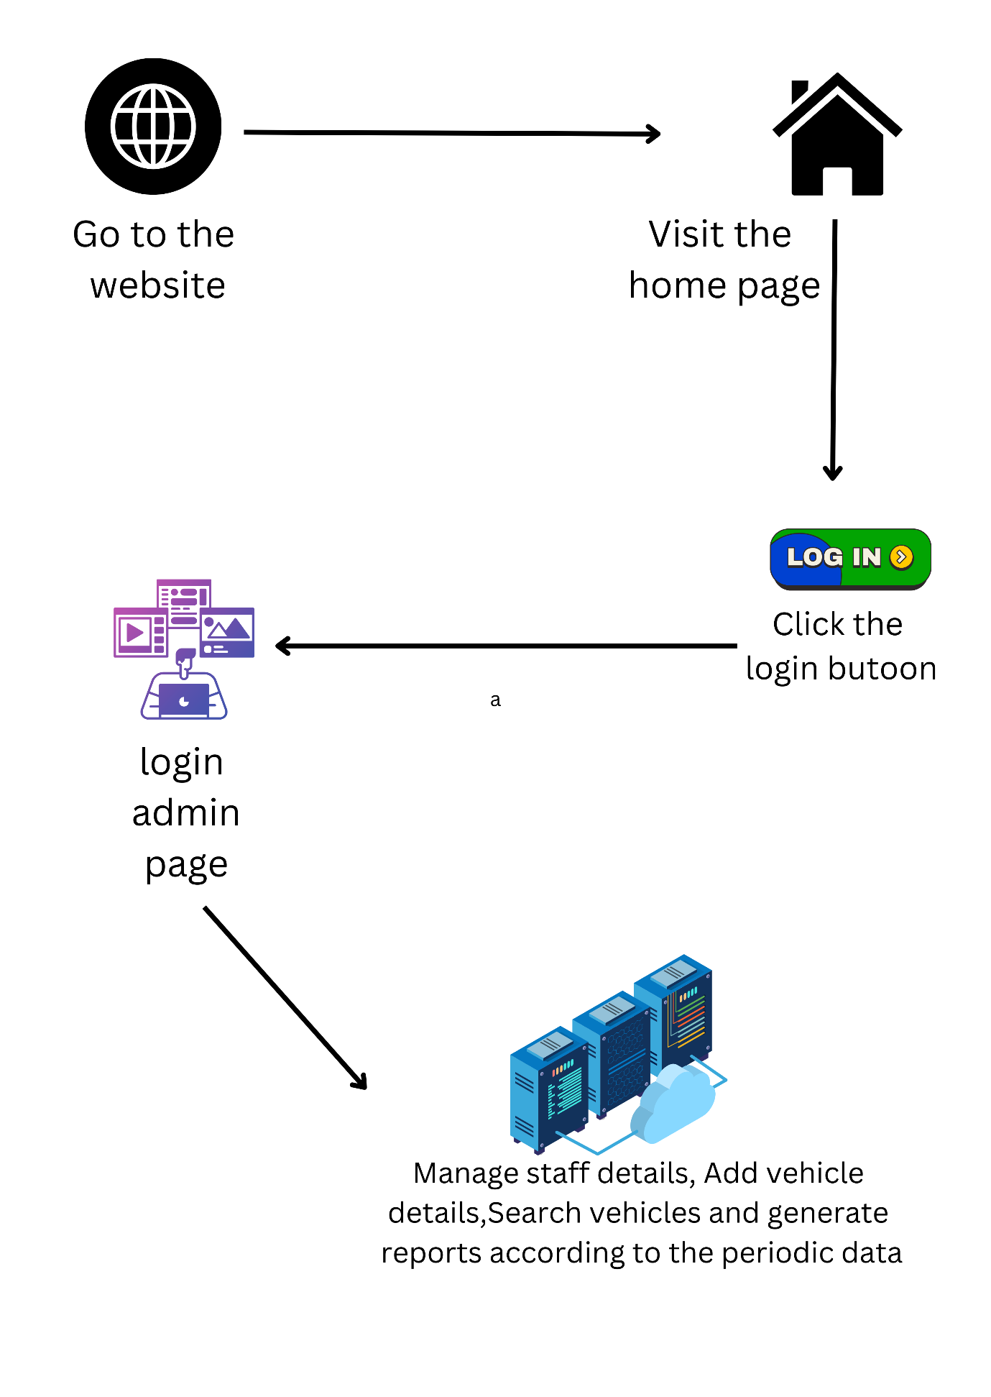

* 1. Support

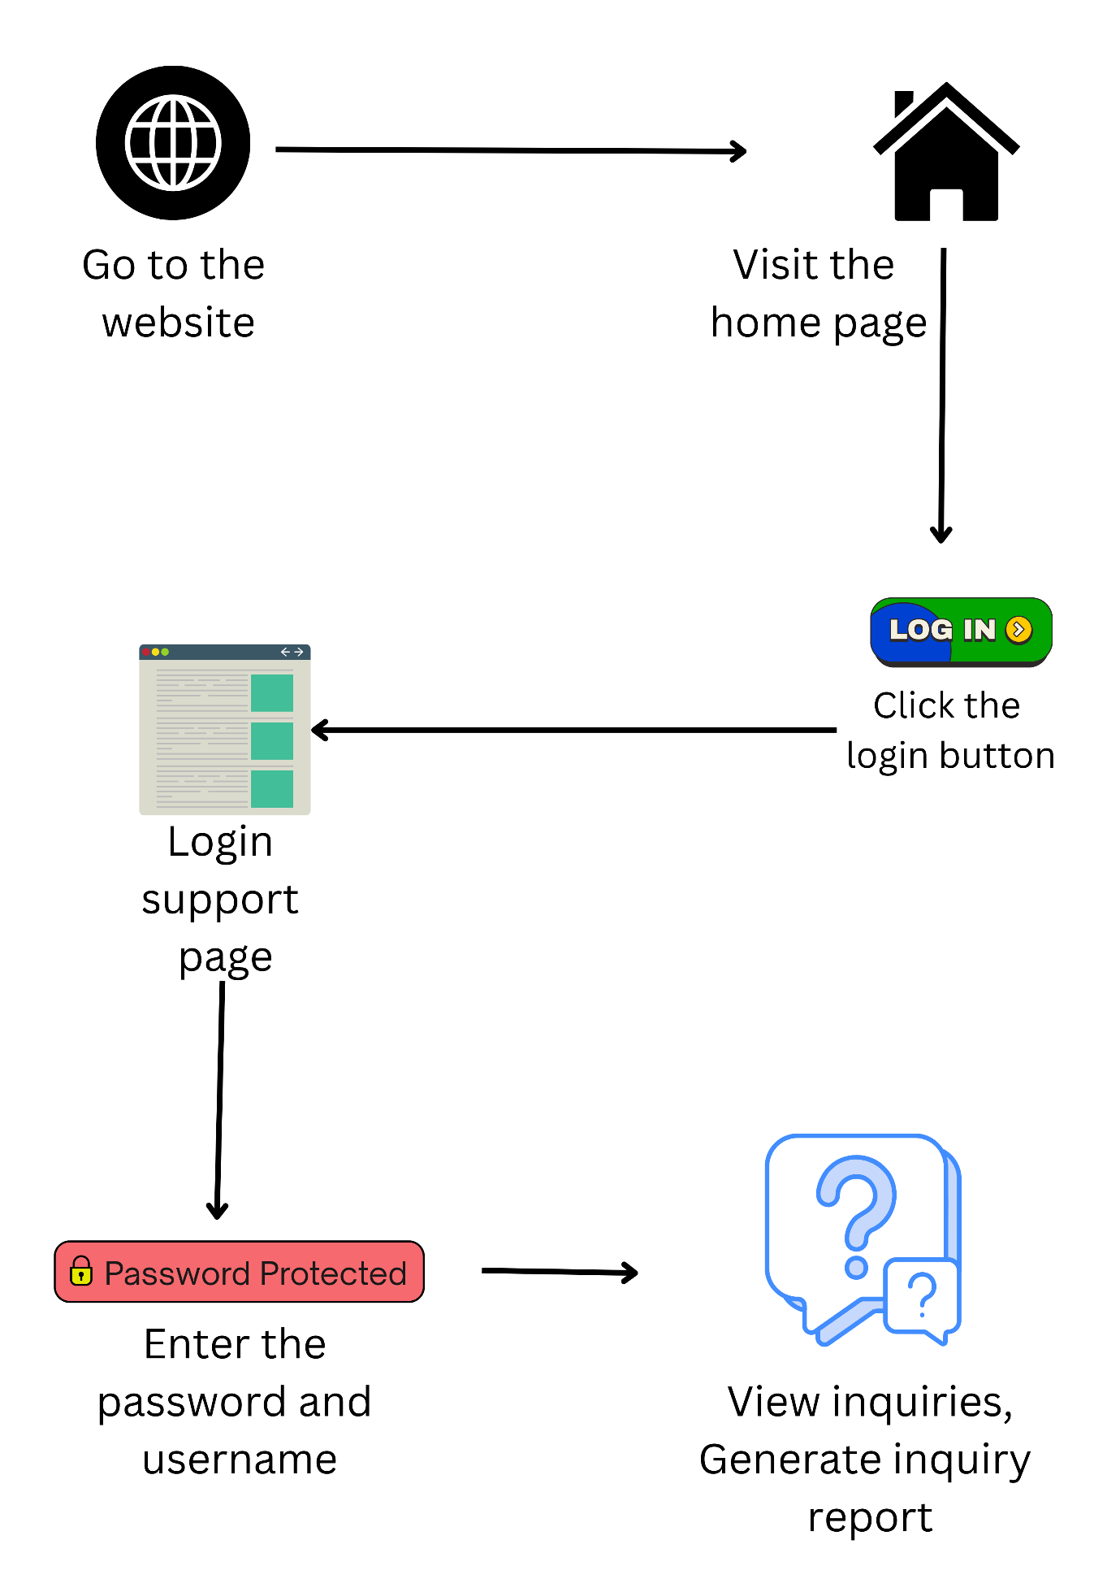

* 1. Security

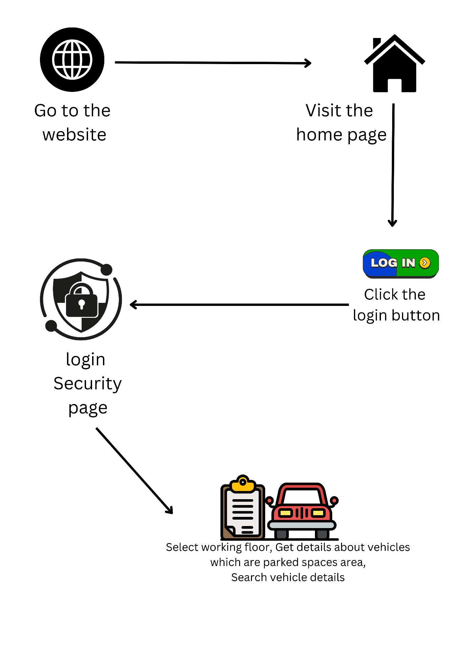

1. **wireframes**

home page

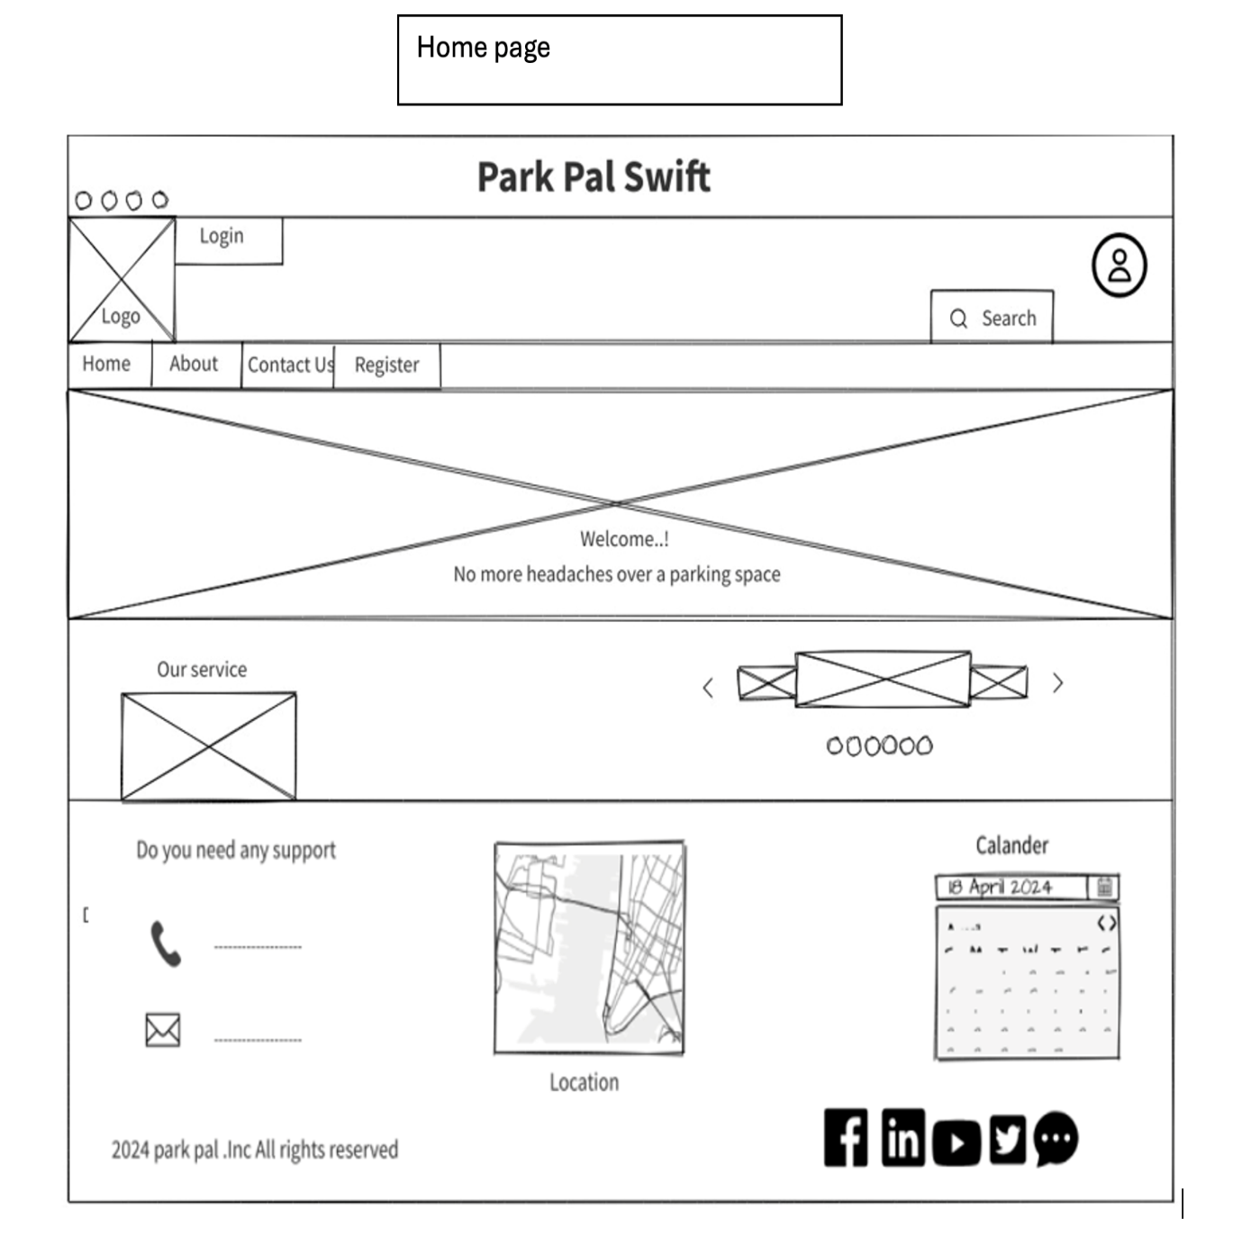

About us page

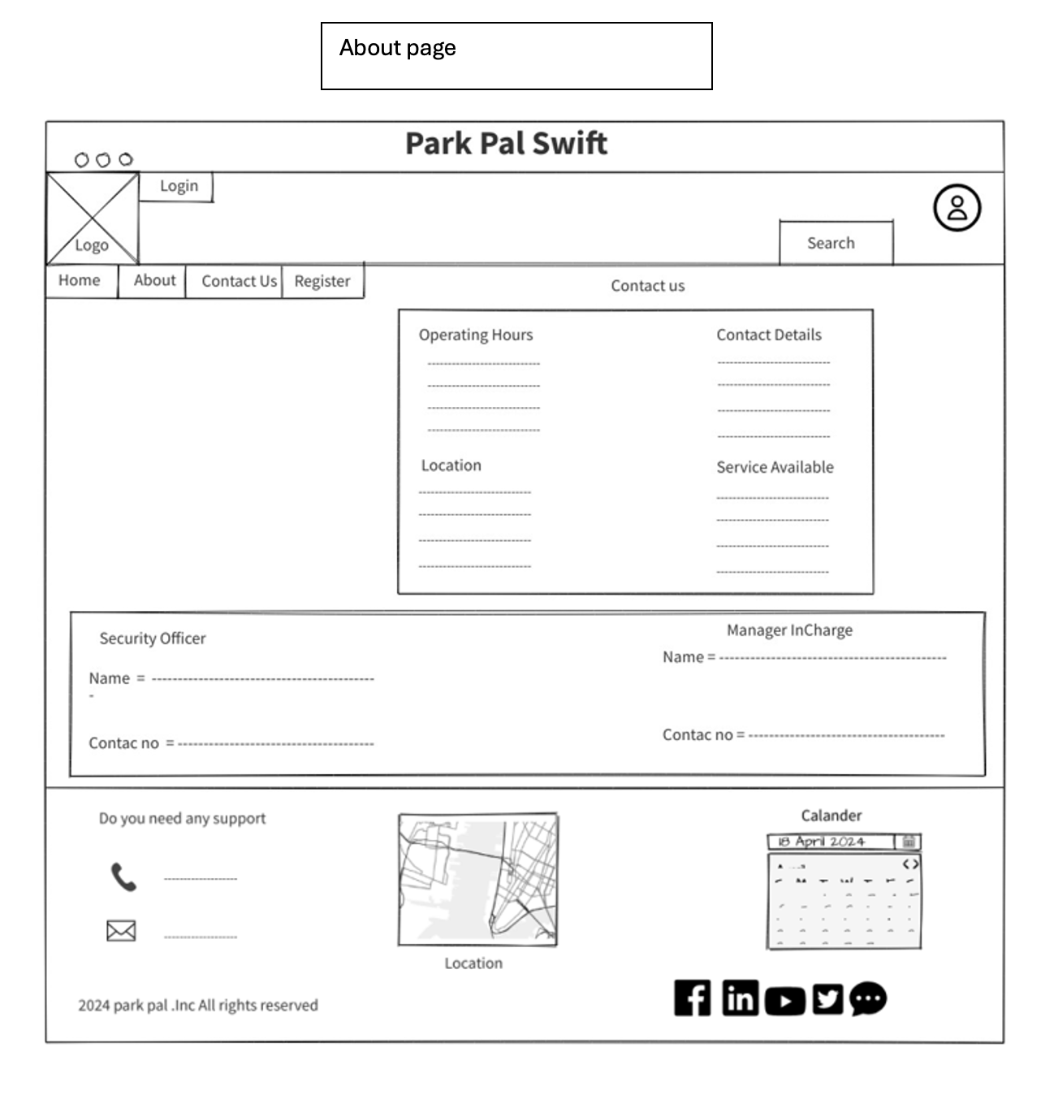

Register page

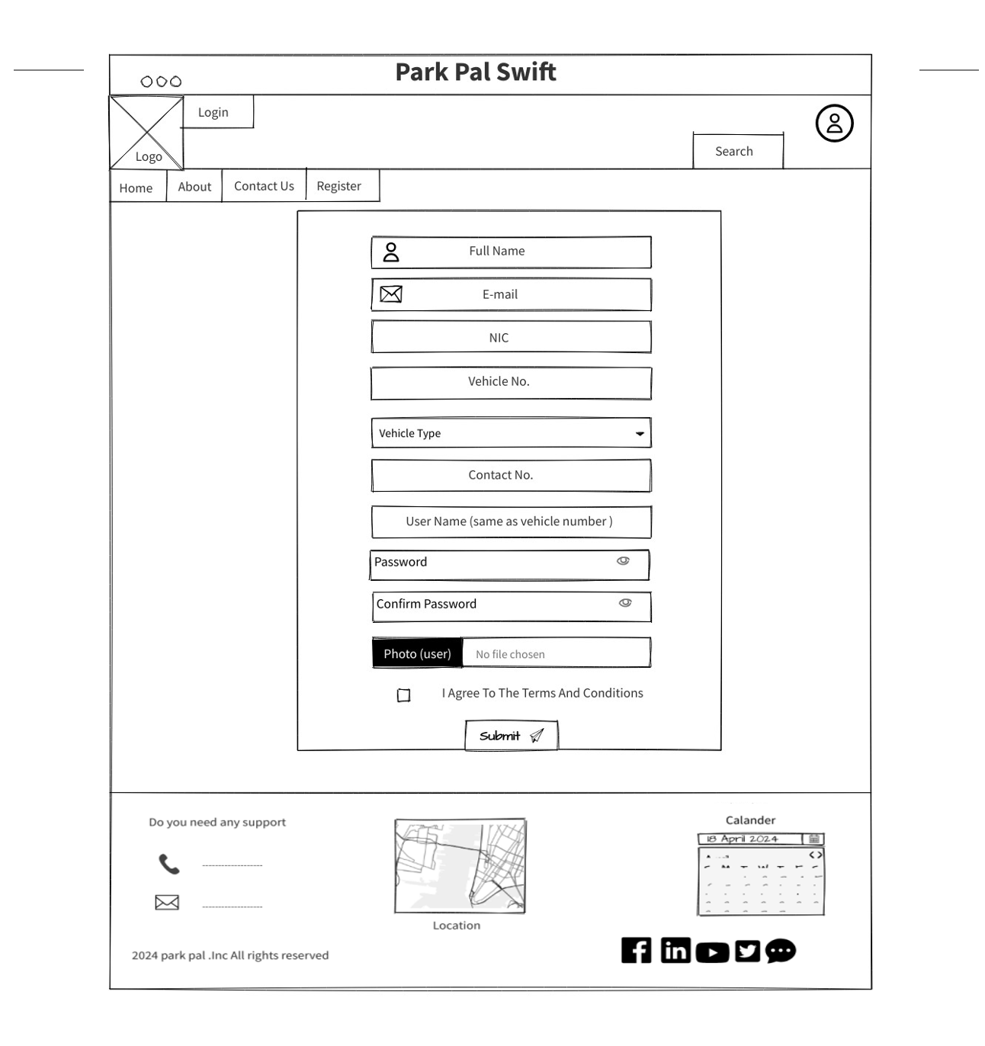

Login page

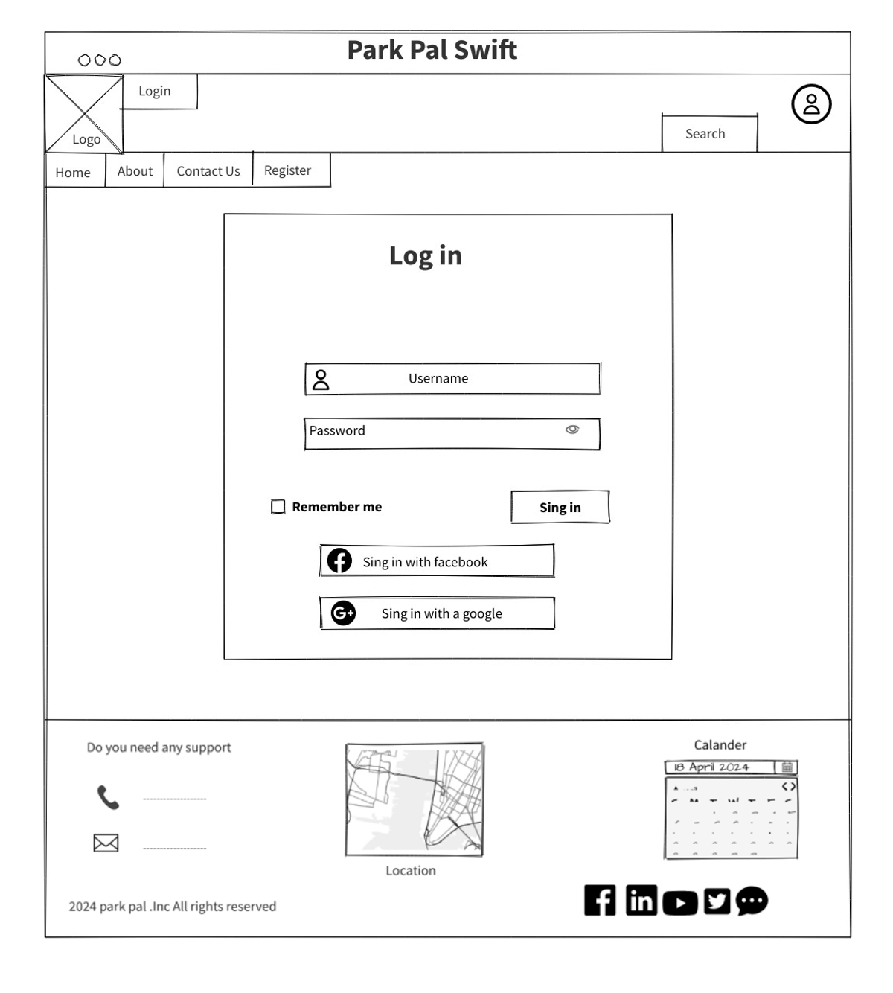

User profile page

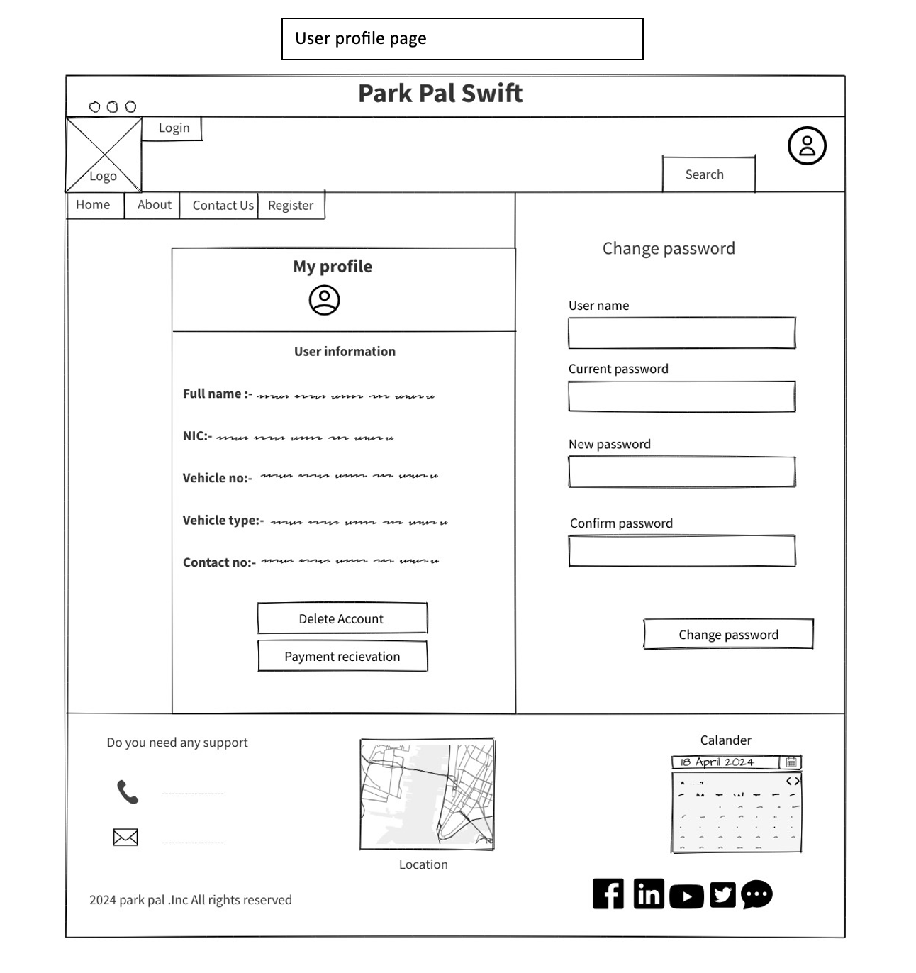

Reservation page

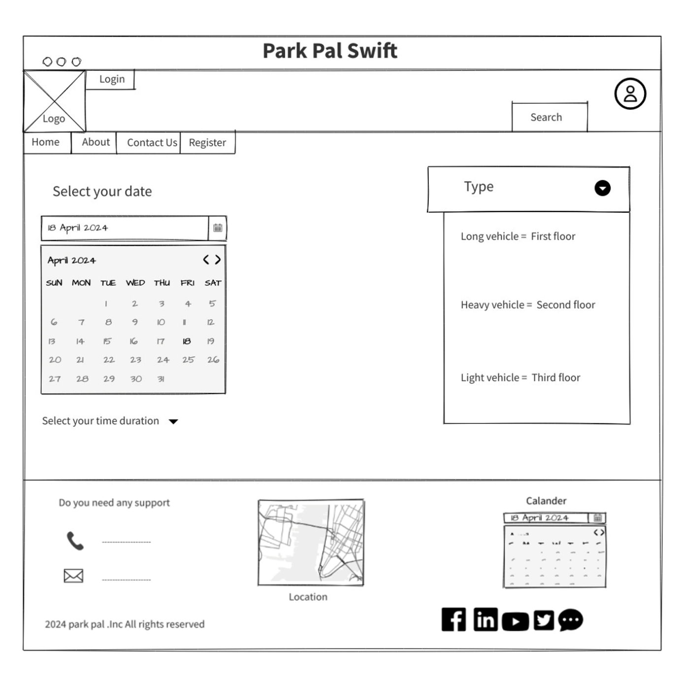

Payment page

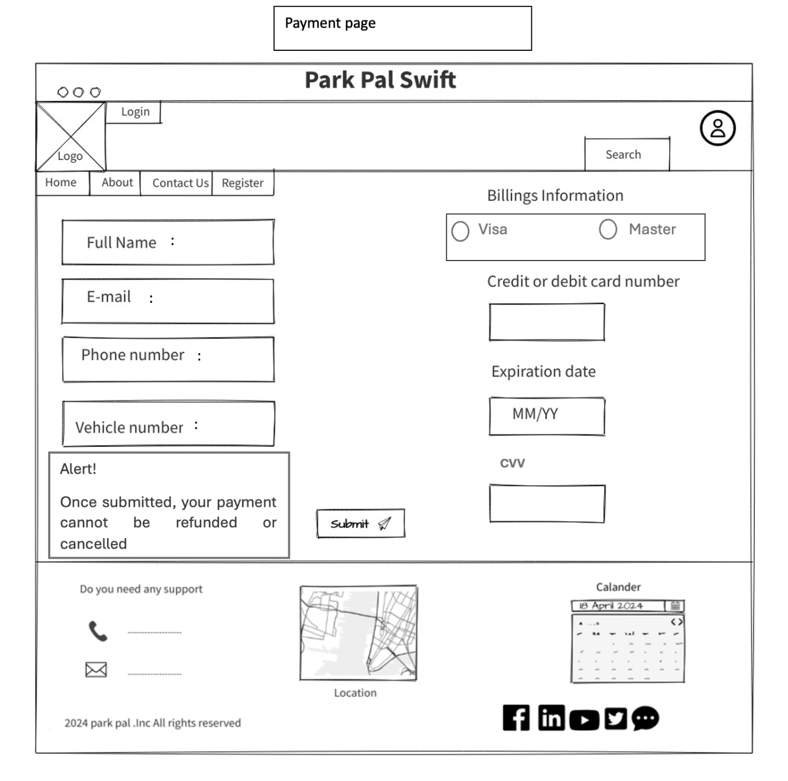

Security page

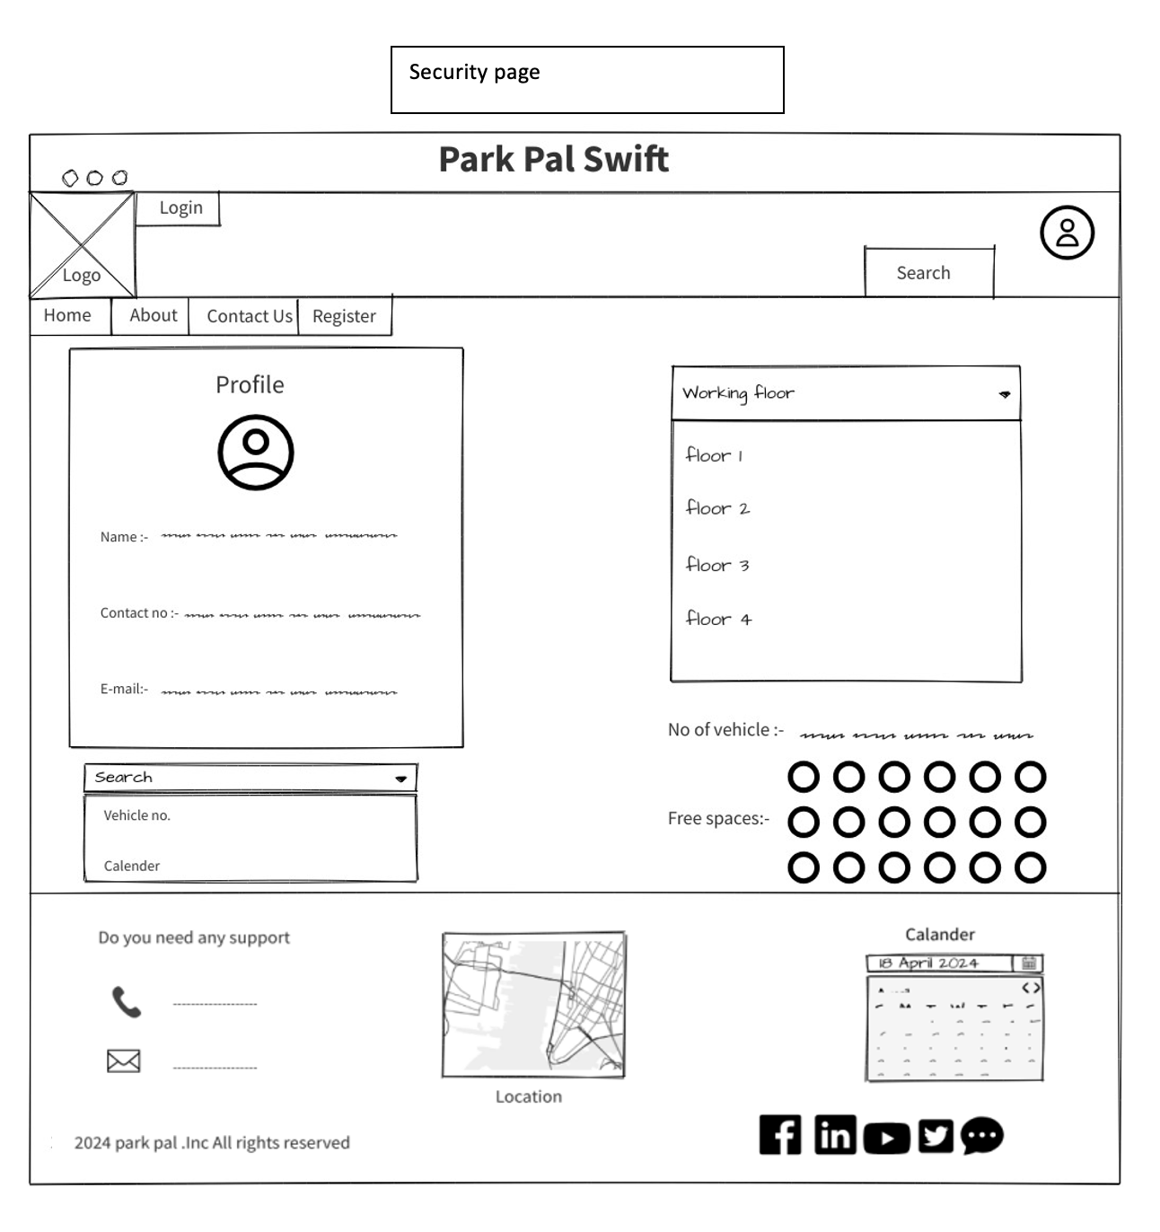

Admin dashboard

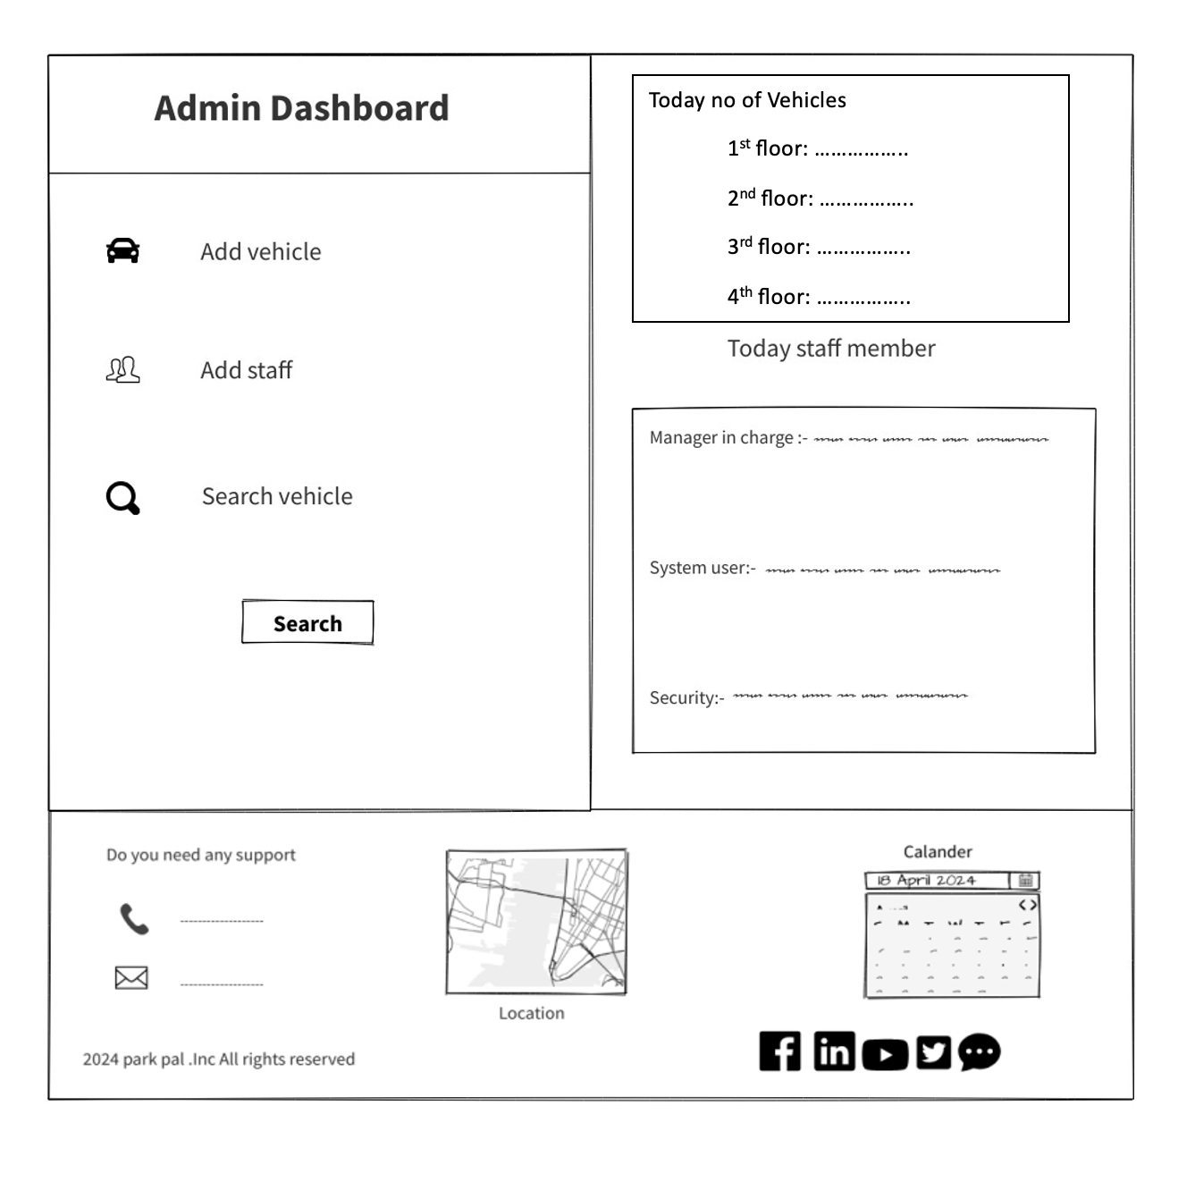

Search page

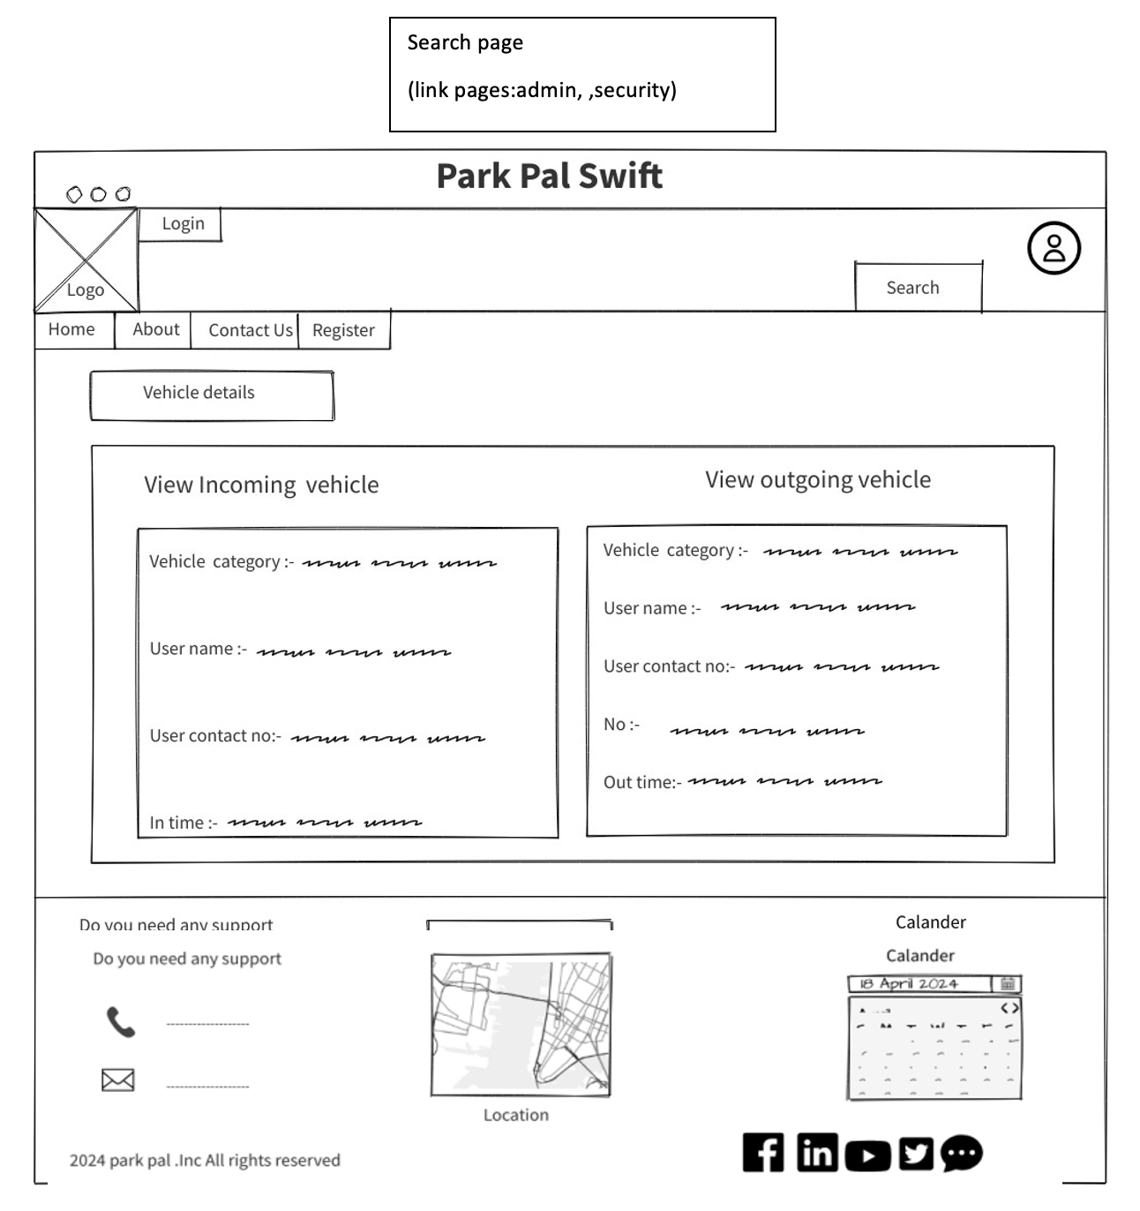

Add vehicle page

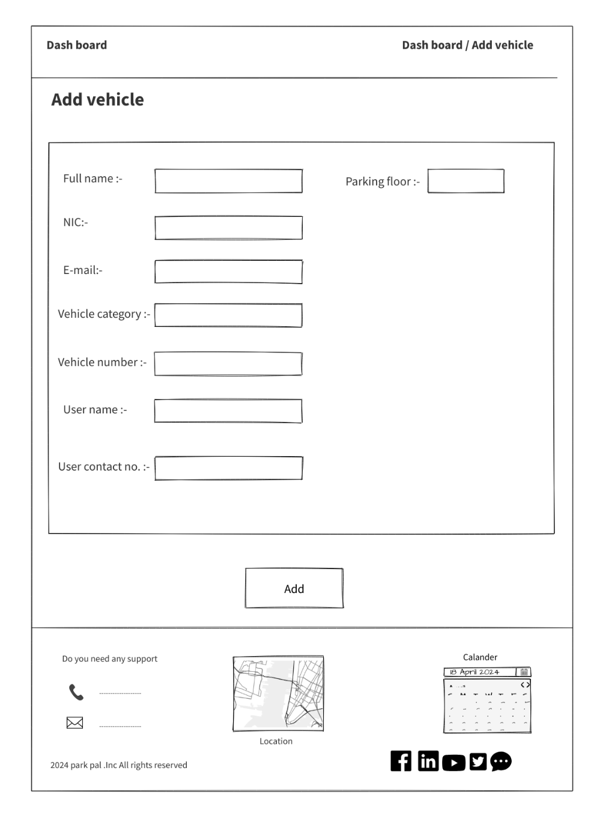

System user page

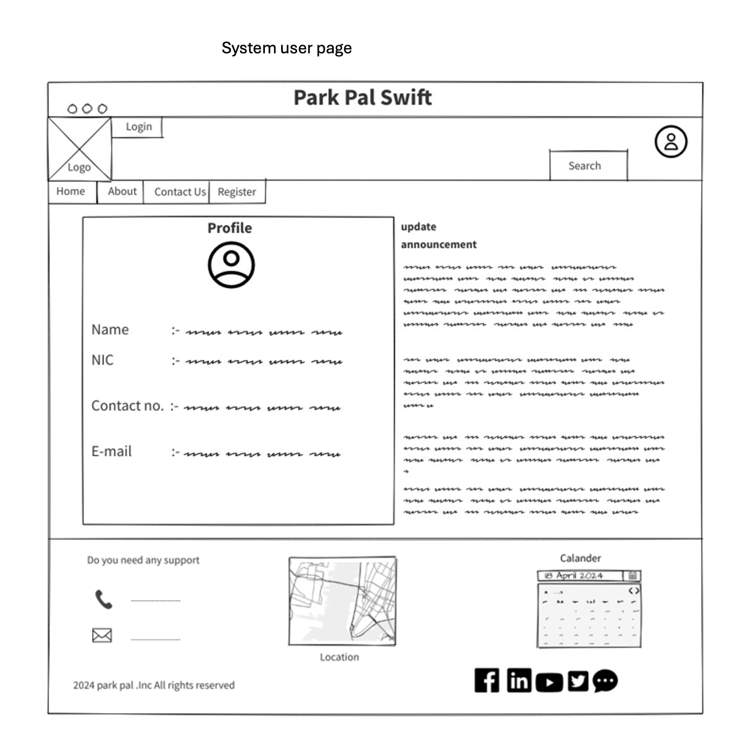

Inquiry page

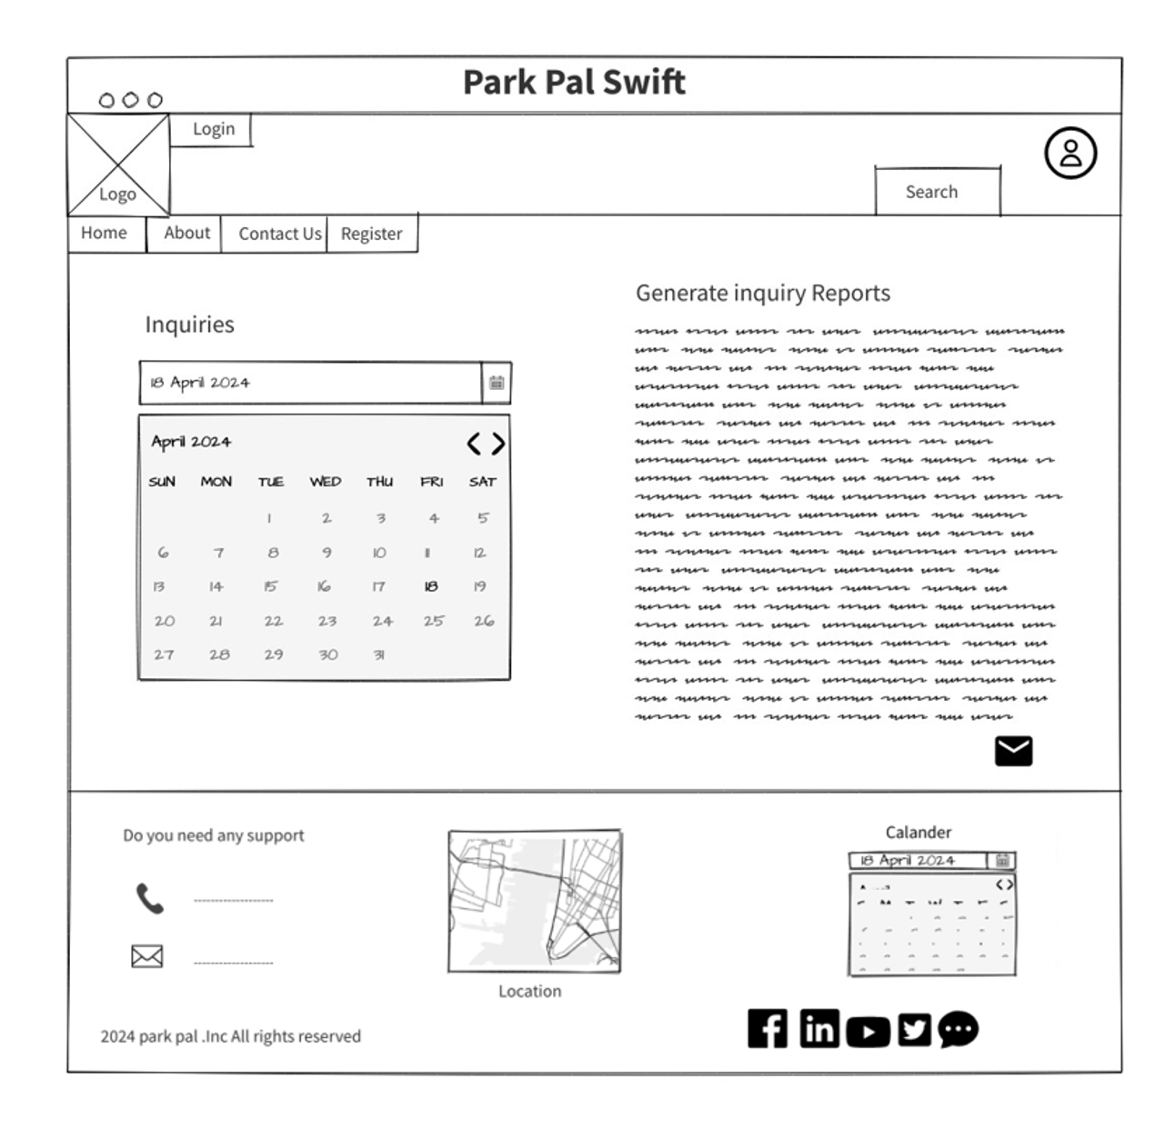

Help and support page

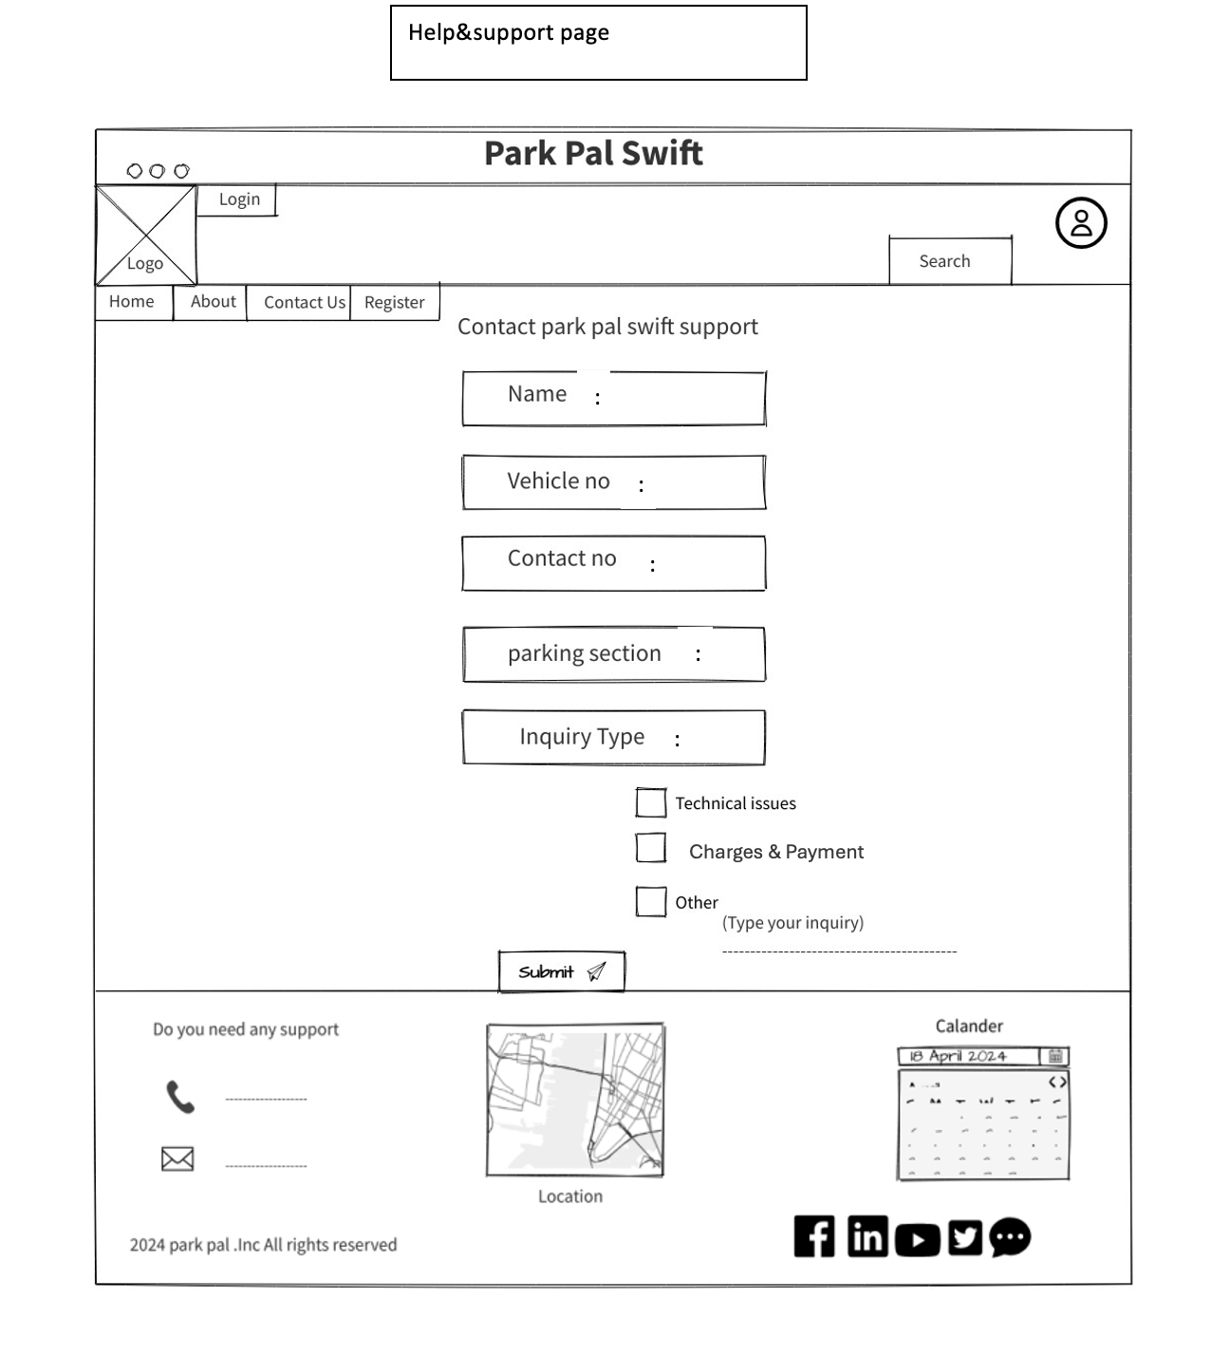

Contact us page

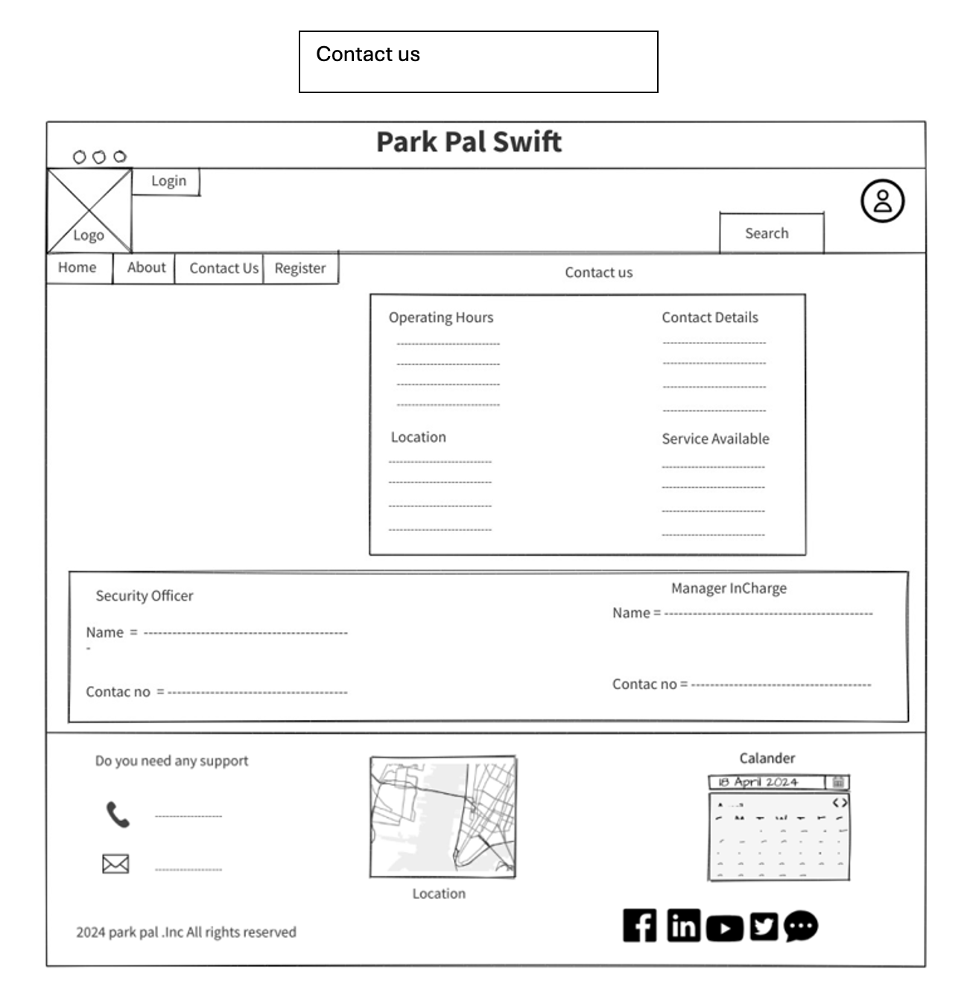

Terms and conditions page

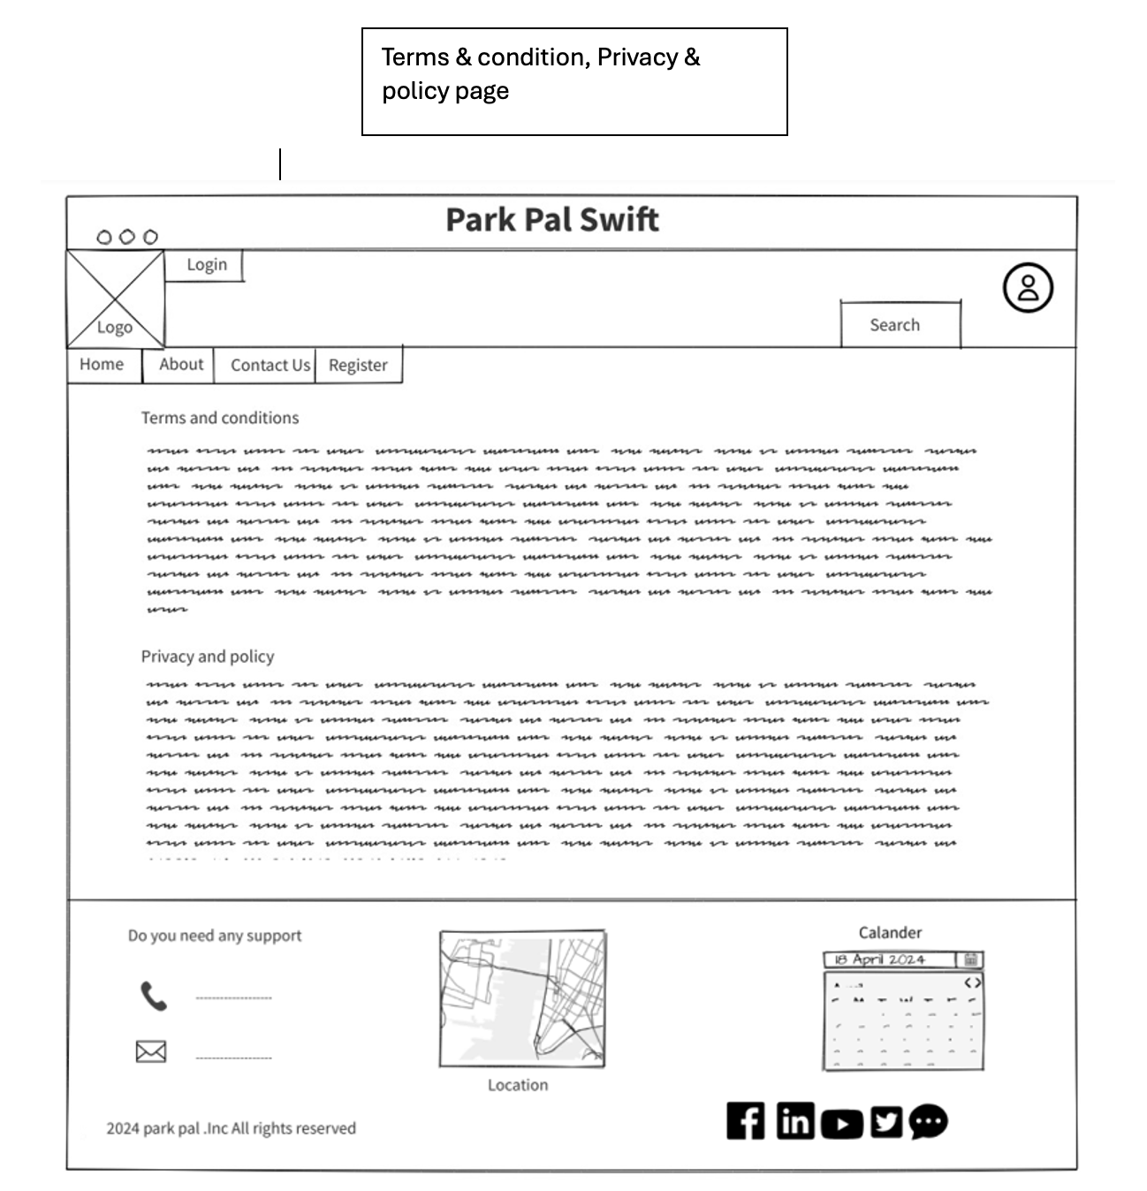

# **Individual Contribution**

|  |  |  |  |
| --- | --- | --- | --- |
|  | **Student ID** | **Student Name** | **Individual Contribution** |
| 1 | IT23830332 | PATHIRANA P U O R | * Persona: user * User Journey: * Wireframe: home page   About us page  Contact us page |
| 2 | IT23846340 | BANDARA R M K D | * Persona: system user * User Journey: * Wireframe: security page   Admin dashboard  Add vehicle page |
| 3 | IT23844742 | DHARMASENA  S D R H | * Persona: administrator * User Journey: * Wireframe: system user page   Help and support page  Reservation page |
| 4 | IT23725010 | PERERA I V | * Persona: support * User Journey: * Wireframe: payment page   User profile page  Inquiry page |
| 5 | IT23827080 | KURUPPU K A S D | * Persona: security * User Journey: * Wireframe: register page   Login page  Terms and conditions page  Search page |